AI-ASSISTED CODING
ASSIGNMENT-5.1
Ethical Foundations – Responsible AI Coding Practices ---------------------------------------
NAME: Adepu Goutham Sri Bhargav
HALL-TICKET: 2403A510C4
BATCH NO: 05

Task 1:
Use an AI tool to generate a Python program that connects to a weather API.
Prompt:
"Generate code to fetch weather data securely without exposing API keys in the code."
Prompt:
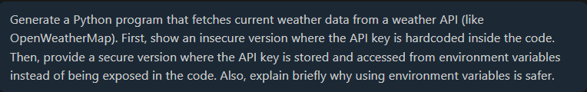

CODE SCREENSHOT:
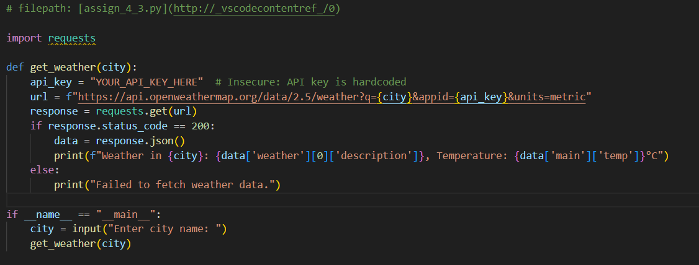
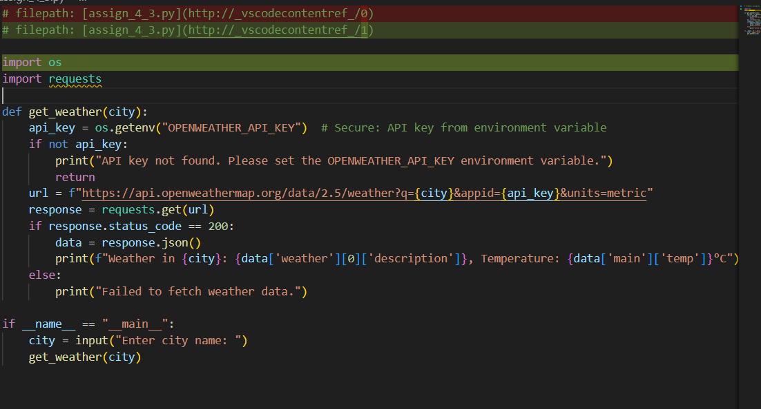
OUTPUT:
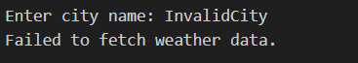

--------------------------------------------------------------------------------------------------------------
Task 2:
Use an AI tool to generate a Python script that stores user data (name, email, password) in a file.
Analyze: Check if the AI stores sensitive data in plain text or without encryption.
Expected Output:
- Identified privacy risks.
- Revised version with encrypted password storage (e.g., hashing).
Prompt:
CODE SCREENSHOT:
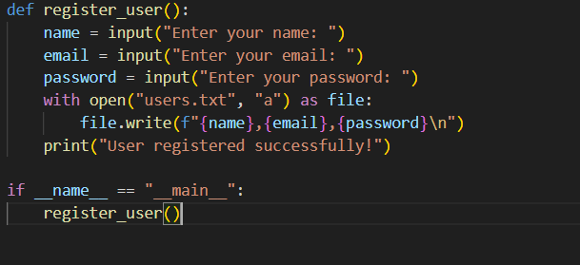
Output:
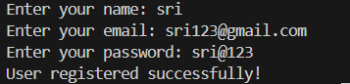
IN the file:
- Plain-text password storage: Passwords are stored exactly as entered.
- No hashing or encryption: A data breach would expose user passwords.
- Vulnerable to insider threats: Anyone with access to the file can read sensitive data.

----------------------------------------------------------------------------------------------------------
Task 3:
Use AI to generate an Armstrong number checking function with comments and explanations.
Instructions:
- Ask AI to explain the code line-by-line.
- Compare the explanation with code functionality.
PROMPT:
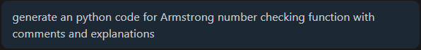
CODE:
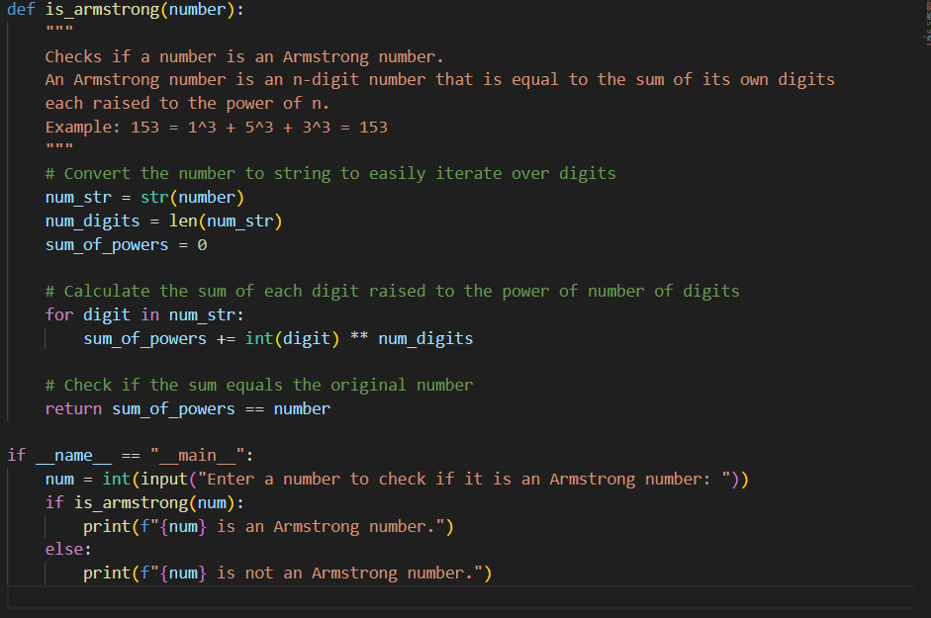

OUTPUT:
------------------------------------------------------------------------------------------------------------------------------------
TASK 4:
Use AI to implement two sorting algorithms (e.g., QuickSort and BubbleSort).
Prompt:
"Generate Python code for QuickSort and BubbleSort, and include comments explaining step-by-step how each works and where they differ."
PROMPT:
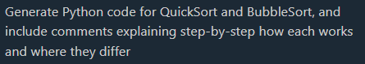
CODE:
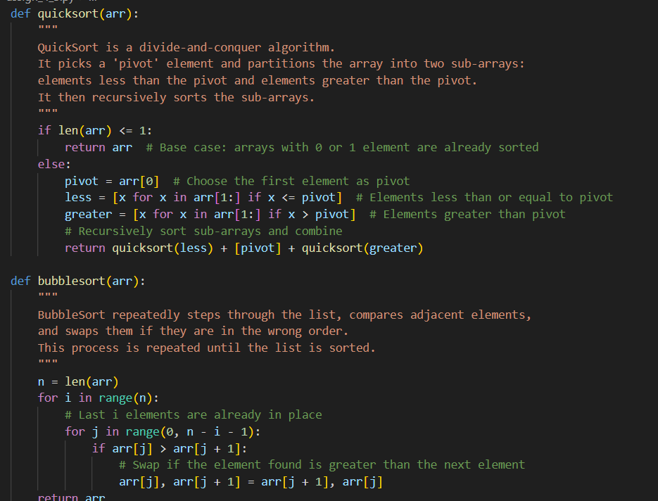
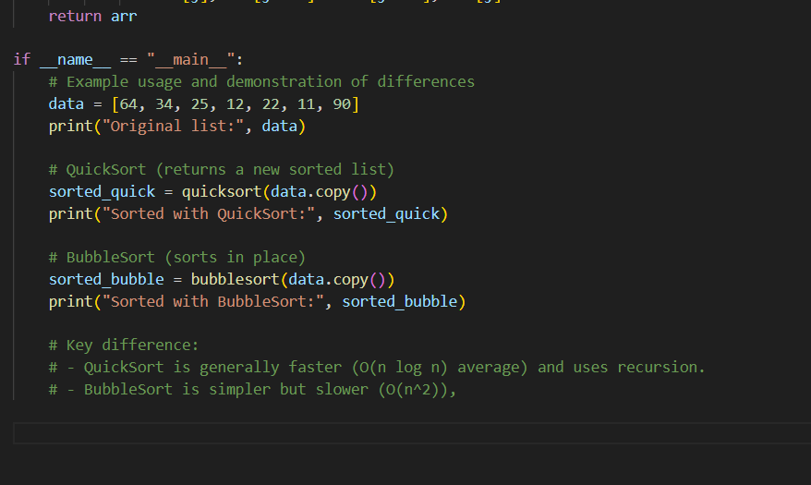
OUTPUT:
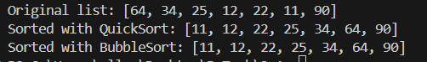

--------------------------------------------------------------------------------------------------------------

TASK 5:
: Use AI to create a product recommendation system.
Prompt:
"Generate a recommendation system that also provides reasons for each suggestion."
Prompt:
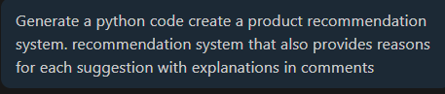
CODE :
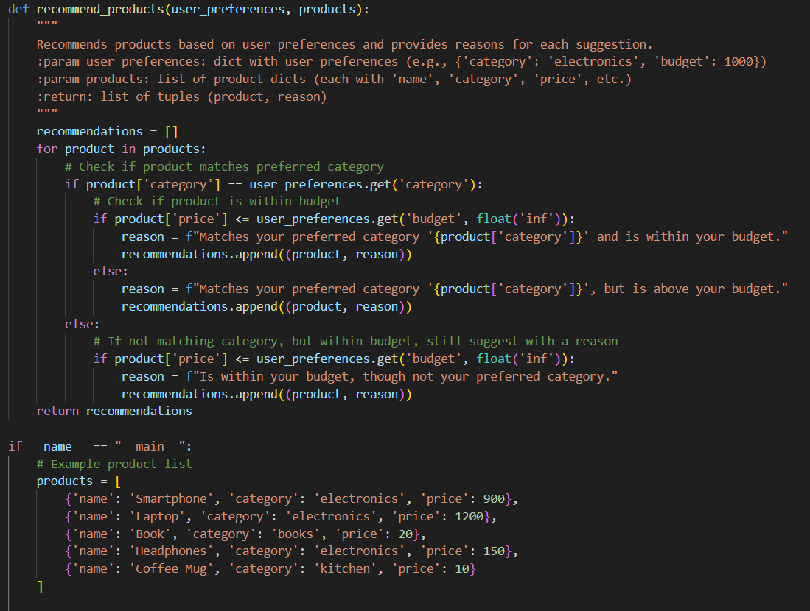
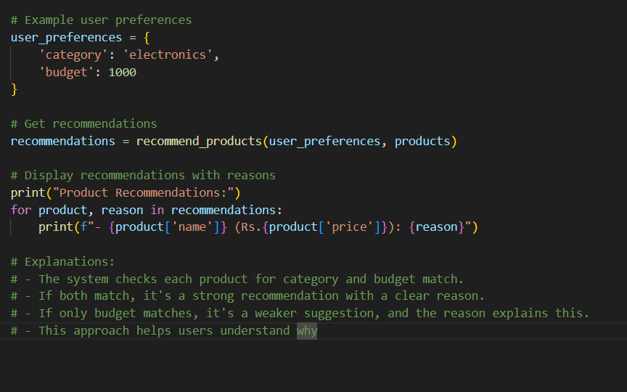
Output:
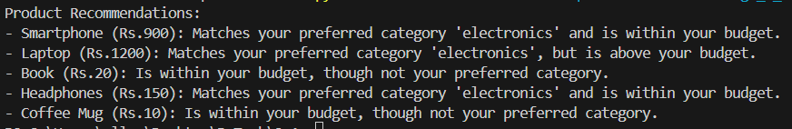
TASK 6:
Ask AI to generate a Python function for calculating factorial using recursion.
Prompt:
"Generate a recursive factorial function with comments that explain each line and a final summary of the algorithm’s flow."

Prompt:
CODE :
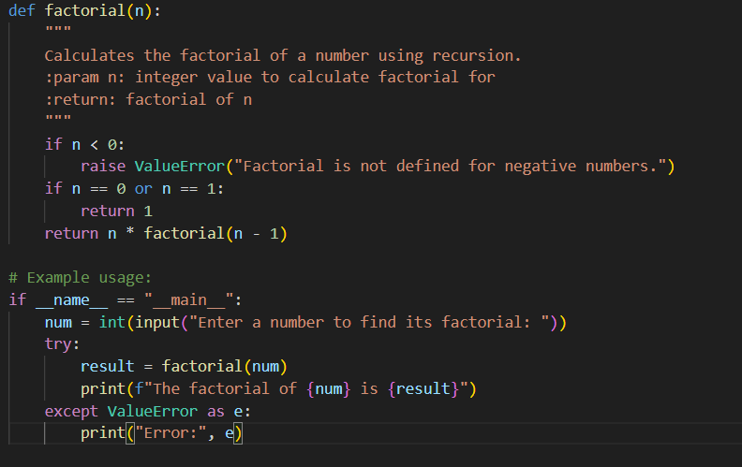
Output:
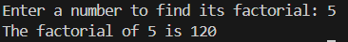
TASK 7:
Code Snippet:

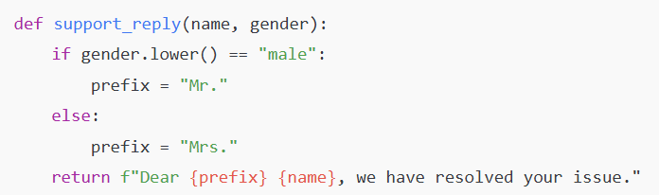

Task:
Regenerate the code so that support messages use neutral language (e.g., “Dear {name}”) and optionally accept preferred titles.
Expected Output:
- Neutral, user-friendly support responses.
Prompt:
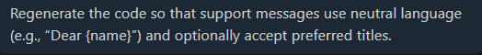
CODE :
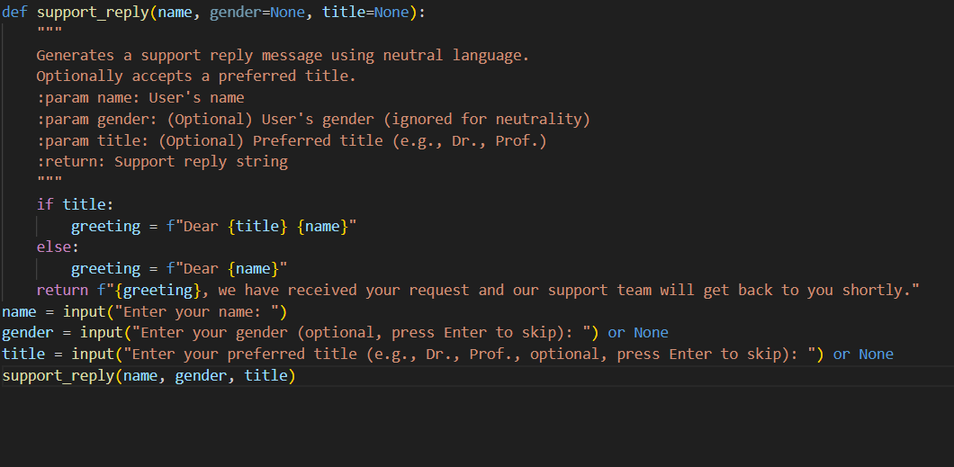
Output:

Note: Report should be submitted a word document for all tasks in a single document with prompts, comments & code explanation, and output and if required, screenshots

